Kubernetes task 1

Minikube status and version:
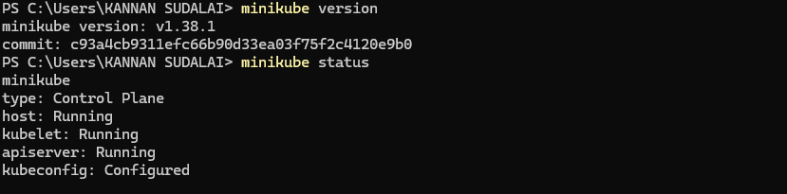
Docker version:
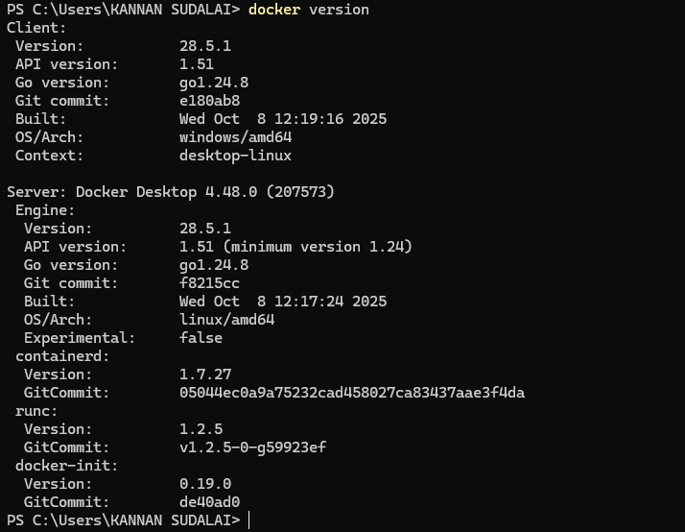

Create namespace “demo”
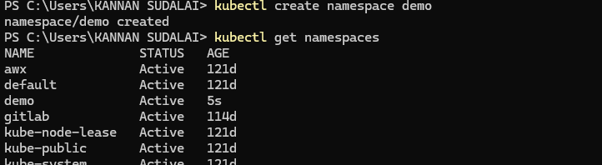

Deploy nginx pod inside demo namespace:
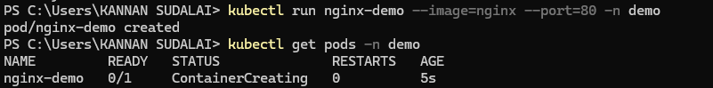

Checking the deployment:
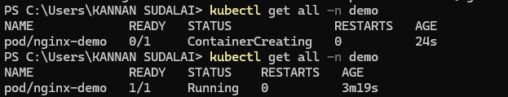

Check its container details:


